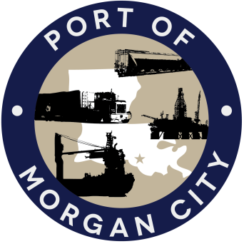

AGENDA

MORGAN CITY HARBOR AND TERMINAL DISTRICT
Regular Meeting of February 13, 2017 – 5:00 p.m. – 7327 Highway 182

- Call to Order

- Roll Call

- Invocation

- Pledge of Allegiance

- Minutes

Regular Meeting of January 9, 2017

- Finance Report
A. Presentation and discussion of financial reports for January 2017 – Deborah Garber
B. Invoices

Guest(s)/Public Comment
A. United States Coast Guard
B. Corps of Engineers, New Orleans District

Raymond “Mac” Wade - Executive Director’s Report

A. Consultant – Michael Knobloch, Knobloch Professional Services, LLC
B. Consultant – Clay Breaud, Providence/GSE
C. Cindy Cutrera, Manager of Economic Development

- Gerard Bourgeois - Legal Report

- New Business

    - Memorial Resolution - Jerry A. Gauthier

- Old Business
A. Discussion and any action on leasing, improvements, maintenance and repairs to facility(ies), including Coast Guard lease(s)
B. Discussion and any action regarding the U.S. Department of Homeland Security grant program, including request for proposals, bids, purchases, project management, generators, computer data system and NOAA ports system(s)
C. Discussion and any action on Government Operations and Emergency Center including bids, purchases, payments, leasing and Facility Planning and Control
D. Discussion and any action on Atchafalaya River Channel dredging and sediment management, including survey services, consulting services and economic study(ies)
E. Discussion and any action on 2016 flood fight

- Adjournment

In accordance with the Americans with Disabilities Act, if you need special assistance, please contact Tori Henry at 985-384-0850, describing the assistance that is necessary.

